Day 3 MCP & Questions
- MCQ: What is the correct order of steps in the Retrieval-Augmented Generation (RAG) process?
- Generation → Indexing → Retrieval → Augmentation
- Indexing → Retrieval → Augmentation → Generation
- Retrieval → Augmentation → Indexing → Generation
- Augmentation → Generation → Indexing → Retrieval

- MCQ: What component acts as the "core component" of RAG to store relative AI data and perform matching?

A) Rule-Based Engine
B) Tokenizer
C) Vector Search / Vector Embedding
D) Scratch Extension
3. MCQ: In the restaurant analogy used in the presentation, what represents the "digital bridge" that lets the AI look up live sources and return clickable responses?
A. The Customer
B. The LLM
C. The Vector Database
D. The API
4.MCQ: What data pipeline and loader tool is explicitly mentioned as being used to format and deliver data to an LLM?
A. Llama Index
B. Twine
C. Teachable Machine
D. PyTorch

5.MCQ: What is the key difference between the data retrieved for an autonomous car search versus an AADHAR validation search?
A) Autonomous cars use text data; AADHAR uses image data.
B) Autonomous car data is public retrieval; AADHAR data is secured data.
C) Autonomous cars do not use APIs; AADHAR does.
D) Autonomous cars use rule-based logic; AADHAR uses RAG
Questions:
1.Explain how an LLM becomes much more useful in real-time applications based on the Day 03 framework, and list two practical examples of an "AI Study Buddy" application.

2.Describe the simple Request-Response process of an API using the AADHAR verification or Mobile OTP verification example from the presentation.

3.Why does an AI system need to ingest raw files, PDFs, images, and video links into a Vector DB before rendering a complex RAG-based output?
Multiple-Choice Questions (MCQs): Answers
- Answer: B) Indexing → Retrieval → Augmentation → Generation
Explanation: As shown in the RAG slide, documents must first be split and stored (Indexing), then relevant blocks are searched (Retrieval), combined with the prompt (Augmentation), and finally passed to the LLM (Generation).
- Answer: C) Vector Search / Vector Embedding
Explanation: The presentation notes state that relative AI data storing and matching is called Vector Search / Vector Embedding, which is a core component of RAG.
- Answer: D) The API
Explanation: The slide defines the API as a "digital bridge" that leaves its own system to look up live sources and return responses.
- Answer: A) Llama Index
Explanation: Llama Index is explicitly mentioned under the Data section as a data pipeline and loader used to format and deliver data.
- Answer: B) Autonomous car data is public retrieval; AADHAR data is secured data.
Explanation: The presentation notes highlight that autonomous car searches look up public data, whereas the banking/AADHAR example deals with secured, authenticated data.

Answers for Questions
- Answer: An LLM becomes significantly more useful when it connects to external data, models, or tools instead of relying solely on its static training. Two practical examples of an "AI Study Buddy" are generating summaries from uploaded notes and creating practice quiz questions.

- Answer: The user triggers a request by entering information (like a mobile number or DOB) on an external site. The API acts as a messenger, passing this data to the authenticated government database (UIDAI), which validates the identity and sends a unique 4–6-digit OTP or confirmation response back to the application.

- Answer: Complex RAG outputs rely on context from diverse data streams (text, PDFs, images, YouTube links). The system must ingest, chunk, and convert this multi-format data into mathematical coordinates (Vector Embeddings) so it can quickly search, match, and feed relevant details into the LLM before generating an answer.

A Sample WebSite to Publish for Student :

https://www.canva.com/website-builder/

https://www.canva.com/design/DAHUETAZlII/-m3Y-FesDliGSi74W90URw/edit

https://srifoundation-ai.my.canva.site/hi-i-am-student-of-aps-colege-polytechnic

APSC College Web Link: https://www.apsce.ac.in/

Sports Corner: https://www.apsce.ac.in/index.php/students_corner/sports

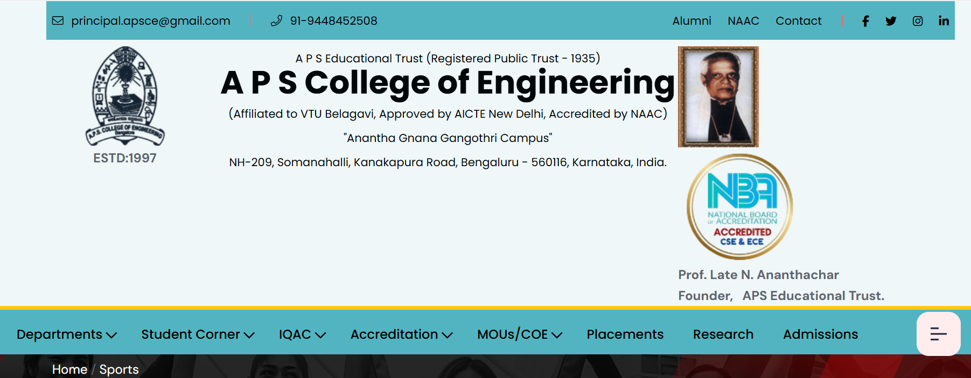

After Admissions Hyper Link, have GuestsLectures hyper link and when we Click on GuestLectures, separate page should open where the first one should be

Print this after 2-3 lines below

AI Related GuestLectures by Srivatsan Madhavan attended by APS Polytechnic 7th Semester Students.

https://srifoundation-ai.my.canva.site

